**Mixed-Radix Cooley-Tukey FFT**

When the desired DFT length  can be expressed as a product of smaller integers, the CooleyTukey decomposition provides what is called a *mixed radix* Cooley-Tukey FFT algorithm.A.2

Two basic varieties of Cooley-Tukey FFT are *decimation in time* (DIT) and its Fourier dual, *decimation in frequency* (DIF). The next section illustrates decimation in time.

# Decimation in Time

The DFT is defined by

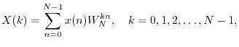

where  is the input signal amplitude at time , and



Note that .

When  is even, the DFT summation can be split into sums over the odd and even indexes of the input signal:

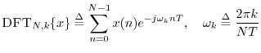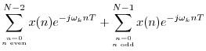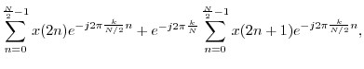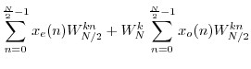

(A.1)

where



and



denote the even- and odd-indexed samples from



.

Thus, the length



DFT is computable using two length



DFTs. The complex factors



are called

*twiddle factors*

. The splitting into sums over even and odd

time indexes is called

*decimation in time*

. (For

*decimation in frequency*

, the inverse DFT of the

spectrum



is split into sums over even and odd

*bin numbers*



.)

# Radix 2 FFT

When  is a power of , say where  is an integer, then the above DIT decomposition can be performed  times, until each DFT is length . A length  DFT requires no multiplies.



The overall result is called a *radix 2 FFT*. A different radix 2 FFT is derived by performing decimation in frequency.

A *split radix* FFT is theoretically more efficient than a pure radix 2 algorithm [73,31] because it minimizes real arithmetic operations. The term ``split radix'' refers to a DIT decomposition that combines portions of one radix 2 and two radix 4 FFTs [22].A.3On modern general-purpose processors, however, computation time is often not minimized by minimizing the arithmetic operation count (see §A.7 below).

**Radix 2 FFT Complexity is N Log N**

Putting together the length  DFT from the  length- DFTs in a radix-2 FFT, the only multiplies

needed are those used to combine two small DFTs to make a DFT twice as long, as in Eq.(A.1). Since there are approximately (complex) multiplies needed for each stage of the DIT decomposition, and only stages of DIT (where denotes the log-base-2 of ), we see that the total number of multiplies for a length  DFT is reduced from to , where means ``on the order of ''. More precisely, a complexity of means that given any



implementation of a length- radix-2 FFT, there exist a constant and integer such that the computational complexity satisfies





for all



. In summary, the complexity of the radix-2 FFT is said to be ``N log N'', or



.

## Fixed-Point FFTs and NFFTs

Recall (*e.g.*, from Eq.(6.1)) that the inverse DFT requires a division by  that the forward DFT does not. In fixed-point arithmetic (Appendix G), and when  is a power of 2, dividing by  may be carried out by right-shifting  places in the binary word. Fixed-point implementations of the

inverse Fast Fourier Transforms (FFT) (Appendix A) typically right-shift one place after each Butterfly stage. However, superior overall numerical performance may be obtained by right-shifting after every *other* butterfly stage [8], which corresponds to dividing both the forward and inverse FFT by  (*i.e.*,  is implemented by *half* as many right shifts as dividing by ). Thus, in fixed-point, numerical

performance can be improved, no extra work is required, and the normalization work (right-shifting) is spread equally between the forward and reverse transform, instead of concentrating all  right-shifts in the inverse transform. The NDFT is therefore quite attractive for fixed-point implementations.

Because signal amplitude can grow by a factor of 2 from one butterfly stage to the next, an extra guard bit is needed for each pair of subsequent NDFT butterfly stages. Also note that if the DFT length  is not a power of , the number of right-shifts in the forward and reverse transform

| Create account.